|  |  |  |  |  |  |  |  |  |  |  |
| --- | --- | --- | --- | --- | --- | --- | --- | --- | --- | --- |
|  | Monday 28th  October | | Tuesday 29th  October | | Wednesday 30th  October | | Thursday 31th  October | | Friday 1st  November | |
| Breakfast Club  8a.m-9p.m. | £5 | | £5 | | £5 | | £5 | | £5 | |
| Morning  9a.m-12p.m. | Multi Skills | £35 | Forest School  &  Woodland Craft | £35 | Forest School  Pumpkin carving  &  Halloween Craft | £35 | Halloween Party  Spooky Games &  Risky play | £35 | Walk and Talk  Grizedale Forest | £35 |
| Afternoon  12-3p.m. |
| Extended afternoon |  | | 3-4p.m. £5 | | 3-4p.m. £5 | | 3-4p.m. £5 | | 3-4p.m. £5 | |
|  | | 4-5p.m. £5 | | 4-5p.m. £5 | | 4-5p.m. £5 | | 4-5p.m. £5 | |
|  | | 5-6p.m. £5 | | 5-6p.m. £5 | | 5-6p.m. £5 | | 5-6p.m. £5 | |

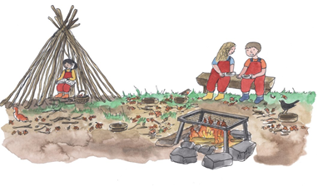

Hawkshead Esthwaite Primary School Holiday Club October Term

You can book single activities or full days!

Breakfast: Children will receive hot or cold cereals/toast with milk or a dairy free alternative and water

Extended afternoon: Child led activities. A light tea will be provided for children staying between 5-6 p.m.